Radiated Emission Test Report

Contents

1. Test lab facility 2

Test Site: 2

Facility name: 2

Facility address: 2

Facility site description: 2

Test Standards 2

EMC Directive 2014/30/EU 2

Test Equipment: 2

Environmental conditions: 3

Test Operator and Date: 3

2. Product Information 3

3. EUT setup 3

Block diagram of test setup for radiated emission: 3

Photograph of EUT: 4

4. Radiated Emission Measurement Results 5

Radiated Emission Limits 5

5. Summary 8

# Test lab facility

## Test Site:

Facility name: Keysight Technology, Technology Order Fulfillment, Colorado Springs Hardware Test Center.

Facility address: 1900 Garden of the Gods Rd, Colorado Springs, CO. 80907

Facility site description:

3 Meter Semi-echoic chamber.

Note: *The radiated RF disturbance measurements were performed on an alternate test site of a semi–anechoic chamber at a 3 m distance. The 3 m test distance on an alternate test site is allowed because the EUT met the definition of small equipment in clause 3.10 and per clause 8.4 of CISPR 11:2009+A1:2010. The alternate test site semi–anechoic chamber meets the volumetric NSA validation requirements in CISPR 16–1–4 for the ±–4 dB from theoretical at all positions and antenna polarizations in the test volume*. *The limit for 10 meter site is adjusted by 10dB to fit 3 meter site.*

## Test Standards

### EMC Directive 2014/30/EU

IEC 61326-1:2012 / EN 61326-1:2013 (Basic) Radiated Emission Reference Standards:

CISPR 11:2009+A1:2010 / EN 55011:2009+A1:2010 Group 1 Class A. The products were tested in a typical configuration with Keysight Technologies test systems. This product is intended for use in a basic electromagnetic environment.

## Test Equipment:

|  |  |
| --- | --- |
| MXE Receiver Address | USB0::0x0957::0x0f0b::MY51210168::0::INSTR |
| Turn Table Address | gpib8 |
| Antenna Address | gpib9 |
| Traceability |  |
| EMI Receiver | Model:N9038A, SN:MY51210168, Calibration Exp.:1/19/2020 |
| Amplifier | Model:8447D, SN:2443A04192, Calibration Exp.:12/1/2019 |
| Antenna | Model:3142E, SN:156974, Calibration Exp.:10/31/2020 |
| Turntable | Model:2165-1.21, SN:MY00153241, Calibration Exp.:12/2/2019 |
| Antenna Tower | Model:2070B, SN:MY00153245, Calibration Exp.:12/3/2019 |
| System loss calibration date | 4/1/2018 |
| Misc. Information |  |
| Test Standard | CISPER 11 Group 1 Class A RE |
| Test Site | Colorado Springs TOF Hardware Test Center 3 Meter anechoic chamber |
| Test Voltage | 110V |
| Test Software Version | V3.2 |

## Environmental conditions:

Temperature: 72°F; Humidity :50 RH

Note: There will be no effect to the result due to changes in mains voltage or frequency.

## Test Operator and Date:

Operator: Clifford; Report generated at: Aug.09,2019 9:22:25 AM

# Product Information

|  |  |
| --- | --- |
| Product Name: | Storm ECO Mesh mod |
| Product Model: | MSOS804A |
| Product SN: | HTC-SSTORM-PS-1 |
| Project Stage: | SHP |
| Deliver date of the test samples: | 7/11/2019 |
| DUT power: | 110V |
| Auxiliary equipment list: | BNC cables USB keyboard USB cable LAN cable |
| Model numbers covered by the test: | MSOSxxA |
| .-Hardware Difference | N/A |
| .-Software/firmware difference: | N/a |
| .-Cosmetic difference: | NA |
| Test Configuration | ECO Added mesh panel inside |
| Test Software Version | V1.5 |

# EUT setup

## Block diagram of test setup for radiated emission:

The measurement antenna was mounted to a non-conductive mast capable of moving the antenna vertically. Antenna height swept from 1m to 2.2 m and the EUT was rotated from 0 degree to 360 degree. Both horizontal and vertical polarization were tested. The maximum emission was captured.



## Photograph of EUT:



# Radiated Emission Measurement Results

## Radiated Emission Limits

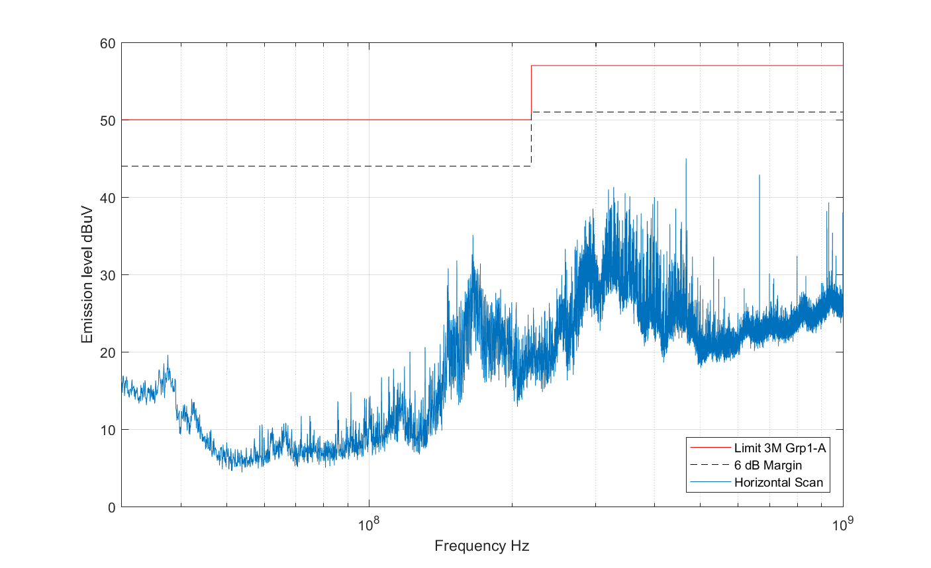

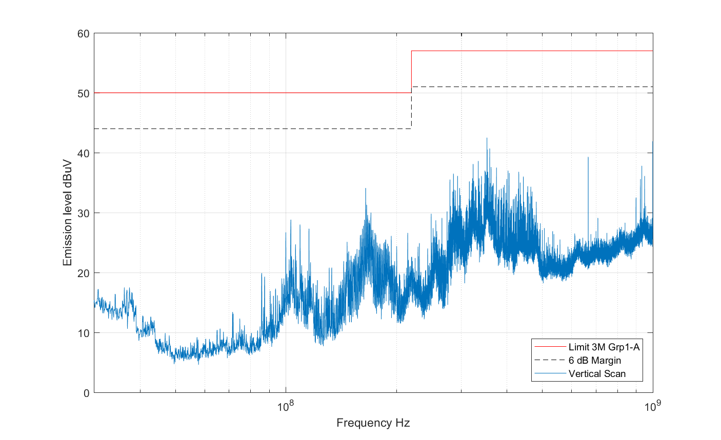

# Summary

The unit Passed the Radiated Emission Test in Horizontal polarization!

The unit passed the Radiated Emission Test in Vertical polarization!